

Selenium Automation Tool

AUDI

Reynah Sharon | Overview | 1/24/20

# Starting the project

## Pre-requisites to IntelliJ with Selenium Webdriver

For that, we need to have some pre-requisites which are as follow.

* IntelliJ IDEA (Community Edition)
* Web browser: Mozilla Firefox
* JDK (Java Development Kit)
* Selenium .jar files (Download from <https://www.seleniumhq.org/download/>)

## Steps to setup Selenium webdriver in local:

1. Copy and paste the folder “auto-ps-na_qa\Test_Selenium_Audi” in local
2. Open the project in IntelliJ
3. Now You need to add the Selenium's .jar files into IntelliJ as external libraries

* For this Click go to File **->** Project Structure **->** in a project setting tab look for Modules **->** Dependencies **->** Click on '+' Sign **->** Select for JARs or directories

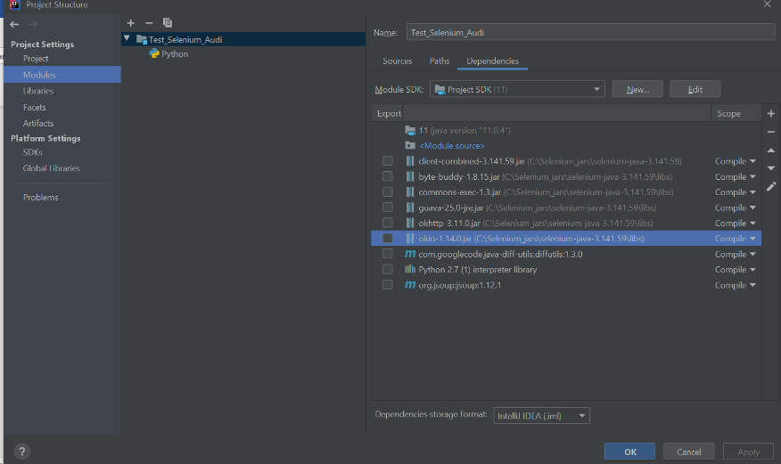

* Select all the selenium .jar files from the directory and subdirectory /lib, where you have extracted after download

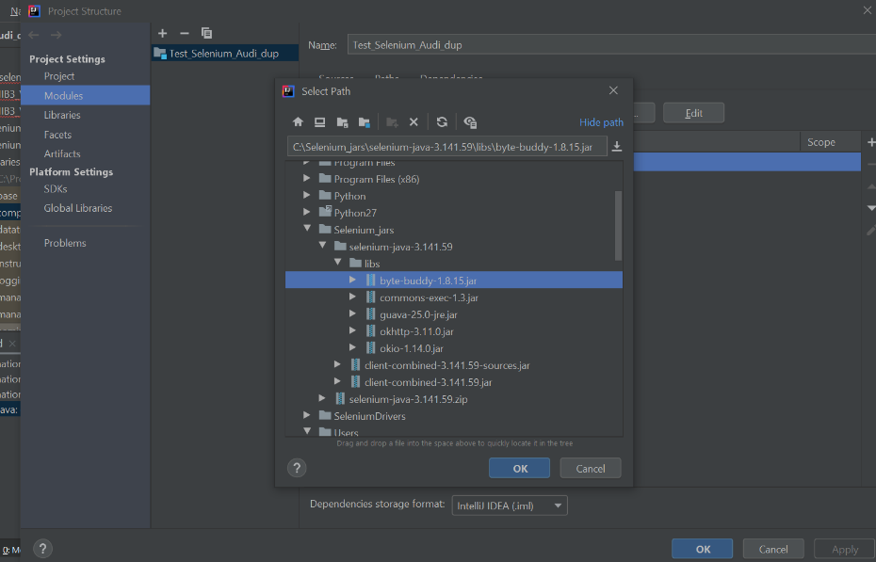

* Now, you have successfully added the .jar files into IntelliJ

1. Click on /src directory (src/com/selenium_for_audi/MIB3_VW_ICAS3_Cloud.java) -> Your project structure will look as shown below

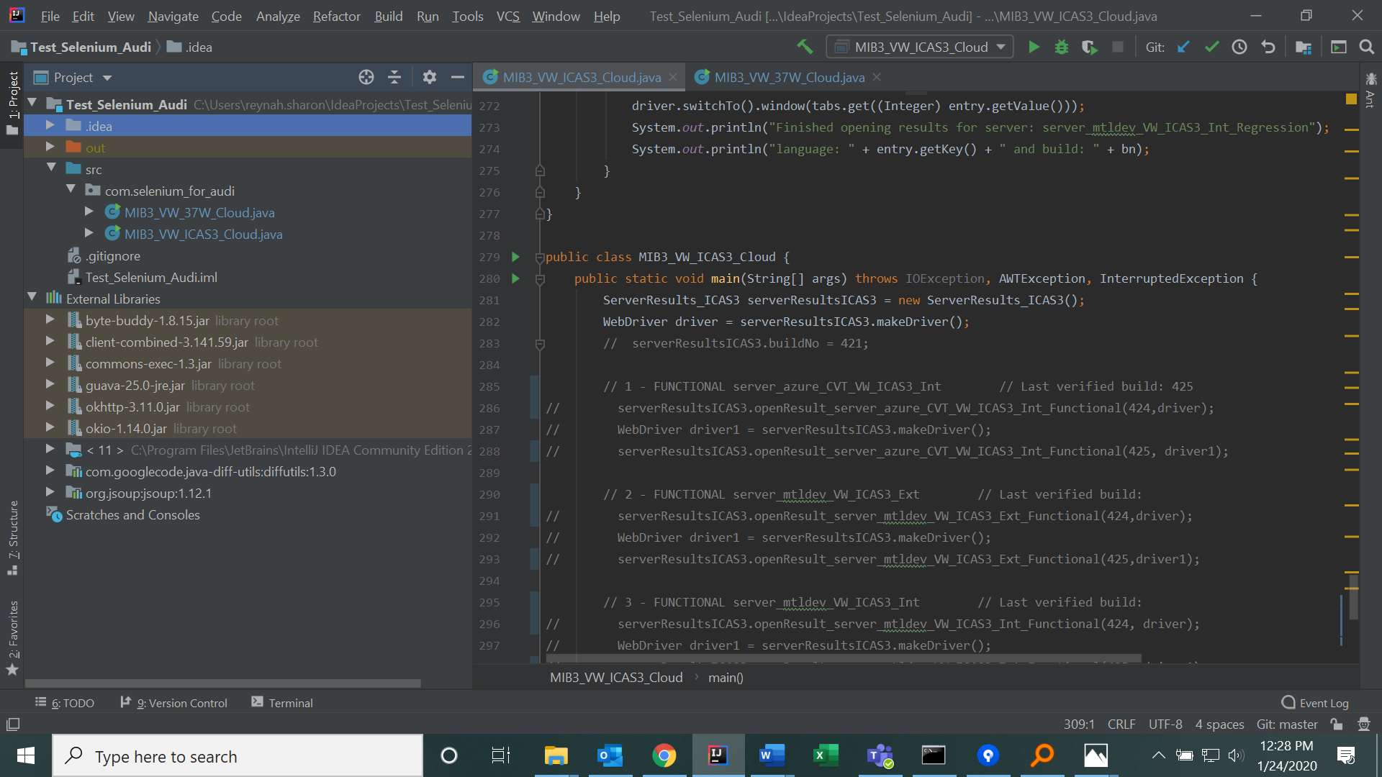

## Daily task: Build results comparison

For daily task we need to compare server results between previous and current build. Up until now there are totally 12 different servers. Each server has around 11 languages. So totally we will be verifying all the languages available on all the servers.

# Project MIB3+ VW-ICAS3 Cloud - Functional

[[Failed](http://gh-dsk0247:8080/job/MIB3+%20VW-ICAS3%20Cloud%20-%20Functional/Language=ALL,Server=server_mtldev_VW_ICAS3_Int,label=master/)Server=server_mtldev_VW_ICAS3_Int](http://gh-dsk0247:8080/job/MIB3+%20VW-ICAS3%20Cloud%20-%20Functional/Language=ALL,Server=server_mtldev_VW_ICAS3_Int,label=master/)

[[Failed](http://gh-dsk0247:8080/job/MIB3+%20VW-ICAS3%20Cloud%20-%20Functional/Language=ALL,Server=server_mtldev_VW_ICAS3_Ext,label=master/)Server=server_mtldev_VW_ICAS3_Ext](http://gh-dsk0247:8080/job/MIB3+%20VW-ICAS3%20Cloud%20-%20Functional/Language=ALL,Server=server_mtldev_VW_ICAS3_Ext,label=master/)

[[Failed](http://gh-dsk0247:8080/job/MIB3+%20VW-ICAS3%20Cloud%20-%20Functional/Language=ALL,Server=server_azure_CVT_VW_ICAS3_Int,label=master/)Server=server_azure_CVT_VW_ICAS3_Int](http://gh-dsk0247:8080/job/MIB3+%20VW-ICAS3%20Cloud%20-%20Functional/Language=ALL,Server=server_azure_CVT_VW_ICAS3_Int,label=master/)

# Project MIB3+ VW-ICAS3 Cloud - Regression

[[Failed](http://gh-dsk0247:8080/job/MIB3+%20VW-ICAS3%20Cloud%20-%20Regression/Language=ALL,Server=server_mtldev_VW_ICAS3_Int,label=master/)Server=server_mtldev_VW_ICAS3_Int](http://gh-dsk0247:8080/job/MIB3+%20VW-ICAS3%20Cloud%20-%20Regression/Language=ALL,Server=server_mtldev_VW_ICAS3_Int,label=master/)

[[Failed](http://gh-dsk0247:8080/job/MIB3+%20VW-ICAS3%20Cloud%20-%20Regression/Language=ALL,Server=server_mtldev_VW_ICAS3_Ext,label=master/)Server=server_mtldev_VW_ICAS3_Ext](http://gh-dsk0247:8080/job/MIB3+%20VW-ICAS3%20Cloud%20-%20Regression/Language=ALL,Server=server_mtldev_VW_ICAS3_Ext,label=master/)

[[Failed](http://gh-dsk0247:8080/job/MIB3+%20VW-ICAS3%20Cloud%20-%20Regression/Language=ALL,Server=server_azure_CVT_VW_ICAS3_Int,label=master/)Server=server_azure_CVT_VW_ICAS3_Int](http://gh-dsk0247:8080/job/MIB3+%20VW-ICAS3%20Cloud%20-%20Regression/Language=ALL,Server=server_azure_CVT_VW_ICAS3_Int,label=master/)

# Project MIB3+ VW-37W Cloud - Functional

[[Failed](http://gh-dsk0247:8080/job/MIB3+%20VW-37W%20Cloud%20-%20Functional/Language=ALL,Server=server_mtldev_VW_37W_InternalPS,label=master/)Server=server_mtldev_VW_37W_InternalPS](http://gh-dsk0247:8080/job/MIB3+%20VW-37W%20Cloud%20-%20Functional/Language=ALL,Server=server_mtldev_VW_37W_InternalPS,label=master/)

[[Failed](http://gh-dsk0247:8080/job/MIB3+%20VW-37W%20Cloud%20-%20Functional/Language=ALL,Server=server_mtldev_VW_37W_External,label=master/)Server=server_mtldev_VW_37W_External](http://gh-dsk0247:8080/job/MIB3+%20VW-37W%20Cloud%20-%20Functional/Language=ALL,Server=server_mtldev_VW_37W_External,label=master/)

[[Failed](http://gh-dsk0247:8080/job/MIB3+%20VW-37W%20Cloud%20-%20Functional/Language=ALL,Server=server_azure_CVT_VW_37W_Internal,label=master/)Server=server_azure_CVT_VW_37W_Internal](http://gh-dsk0247:8080/job/MIB3+%20VW-37W%20Cloud%20-%20Functional/Language=ALL,Server=server_azure_CVT_VW_37W_Internal,label=master/)

# Project MIB3+ VW-37W Cloud - Regression

[[Failed](http://gh-dsk0247:8080/job/MIB3+%20VW-37W%20Cloud%20-%20Regression/Language=ALL,Server=server_mtldev_VW_37W_InternalPS,label=master/)Server=server_mtldev_VW_37W_InternalPS](http://gh-dsk0247:8080/job/MIB3+%20VW-37W%20Cloud%20-%20Regression/Language=ALL,Server=server_mtldev_VW_37W_InternalPS,label=master/)

[[Failed](http://gh-dsk0247:8080/job/MIB3+%20VW-37W%20Cloud%20-%20Regression/Language=ALL,Server=server_mtldev_VW_37W_External,label=master/)Server=server_mtldev_VW_37W_External](http://gh-dsk0247:8080/job/MIB3+%20VW-37W%20Cloud%20-%20Regression/Language=ALL,Server=server_mtldev_VW_37W_External,label=master/)

[[Failed](http://gh-dsk0247:8080/job/MIB3+%20VW-37W%20Cloud%20-%20Regression/Language=ALL,Server=server_azure_CVT_VW_37W_Internal,label=master/)Server=server_azure_CVT_VW_37W_Internal](http://gh-dsk0247:8080/job/MIB3+%20VW-37W%20Cloud%20-%20Regression/Language=ALL,Server=server_azure_CVT_VW_37W_Internal,label=master/)

|  |
| --- |
|  |

## how to run

1. Open class “src/com/selenium_for_audi/MIB3_VW_ICAS3_Cloud.java”
2. Right click -> Select “Run MIB3_VW_ICAS3_Cloud.java”

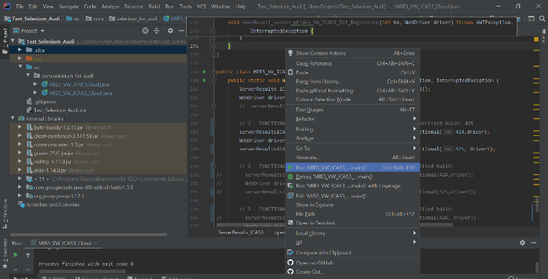

1. Don’t move mouse afterwards until program finishes running as selenium works only on the visible screen space by identifying page elements.
2. After program finishes running, you’ll end up with 2 webpages with the server results opened for 2 different builds. Each tab on webpage corresponds to single language. So, one webpage will have a maximum of 11 tabs
3. Keep both webpages side by side to make things cleaner and start comparing results

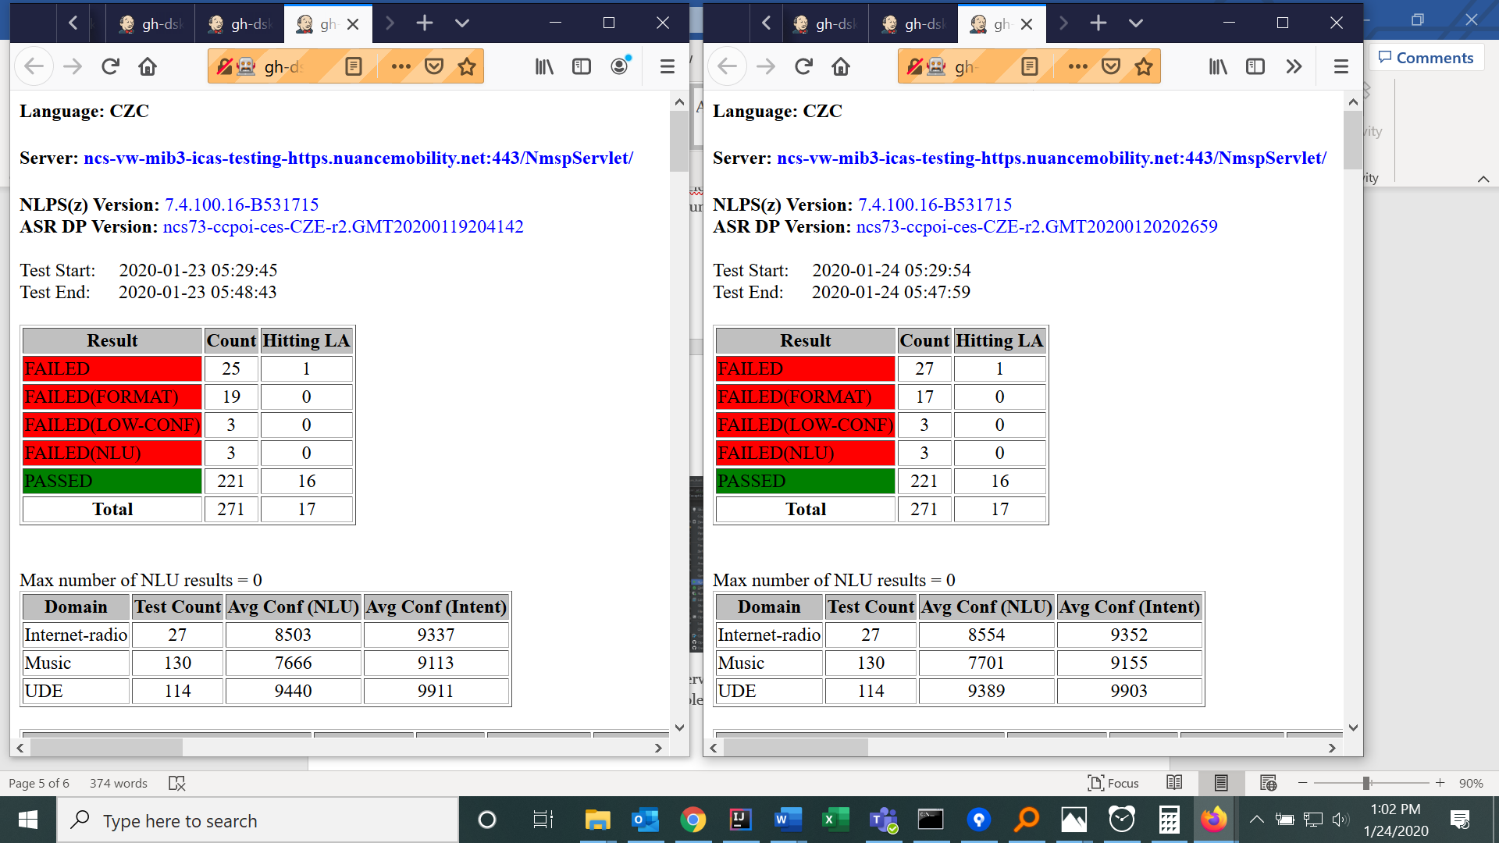

Follow the above steps for each server by uncommenting the code under each server heading at end of class file as shown in following image. There are 2 class files with the following list of servers:

1. MIB3_VW_37W_Cloud.java => [server_mtldev_VW_37W_InternalPS](http://gh-dsk0247:8080/job/MIB3+%20VW-37W%20Cloud%20-%20Functional/Language=ALL,Server=server_mtldev_VW_37W_InternalPS,label=master/), [server_mtldev_VW_37W_External](http://gh-dsk0247:8080/job/MIB3+%20VW-37W%20Cloud%20-%20Functional/Language=ALL,Server=server_mtldev_VW_37W_External,label=master/), [server_azure_CVT_VW_37W_Internal](http://gh-dsk0247:8080/job/MIB3+%20VW-37W%20Cloud%20-%20Functional/Language=ALL,Server=server_azure_CVT_VW_37W_Internal,label=master/), [server_mtldev_VW_37W_InternalPS](http://gh-dsk0247:8080/job/MIB3+%20VW-37W%20Cloud%20-%20Regression/Language=ALL,Server=server_mtldev_VW_37W_InternalPS,label=master/), [server_mtldev_VW_37W_External](http://gh-dsk0247:8080/job/MIB3+%20VW-37W%20Cloud%20-%20Regression/Language=ALL,Server=server_mtldev_VW_37W_External,label=master/), [server_azure_CVT_VW_37W_Internal](http://gh-dsk0247:8080/job/MIB3+%20VW-37W%20Cloud%20-%20Regression/Language=ALL,Server=server_azure_CVT_VW_37W_Internal,label=master/)
2. MIB3_VW_ICAS3_Cloud => [server_mtldev_VW_ICAS3_Int](http://gh-dsk0247:8080/job/MIB3+%20VW-ICAS3%20Cloud%20-%20Functional/Language=ALL,Server=server_mtldev_VW_ICAS3_Int,label=master/) , [server_mtldev_VW_ICAS3_Ext](http://gh-dsk0247:8080/job/MIB3+%20VW-ICAS3%20Cloud%20-%20Functional/Language=ALL,Server=server_mtldev_VW_ICAS3_Ext,label=master/), [server_azure_CVT_VW_ICAS3_Int](http://gh-dsk0247:8080/job/MIB3+%20VW-ICAS3%20Cloud%20-%20Functional/Language=ALL,Server=server_azure_CVT_VW_ICAS3_Int,label=master/), [server_mtldev_VW_ICAS3_Int](http://gh-dsk0247:8080/job/MIB3+%20VW-ICAS3%20Cloud%20-%20Regression/Language=ALL,Server=server_mtldev_VW_ICAS3_Int,label=master/), [server_mtldev_VW_ICAS3_Ext](http://gh-dsk0247:8080/job/MIB3+%20VW-ICAS3%20Cloud%20-%20Regression/Language=ALL,Server=server_mtldev_VW_ICAS3_Ext,label=master/), [server_azure_CVT_VW_ICAS3_Int](http://gh-dsk0247:8080/job/MIB3+%20VW-ICAS3%20Cloud%20-%20Regression/Language=ALL,Server=server_azure_CVT_VW_ICAS3_Int,label=master/)

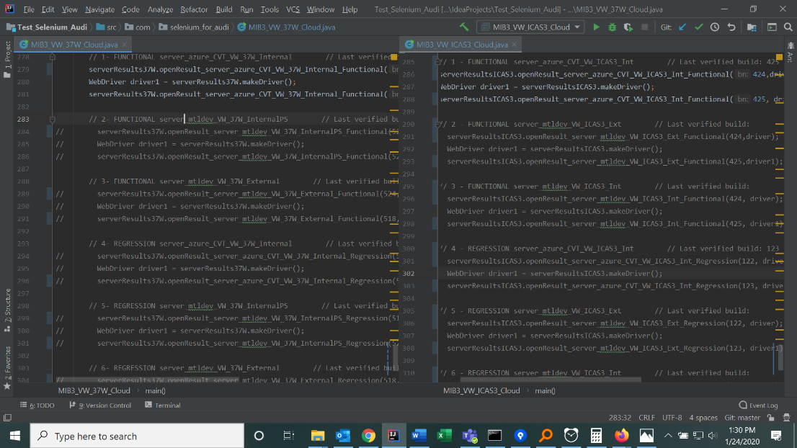

## Appendix:

## Comparison of timing between manual and automation

**Manual Process:**

Time taken to open 2 web pages for side by side verification for a single language:

**40 seconds**

Total time taken for comparing build results of 11 languages on 12 severs:

11 * 12 * 40 = 1 hr 46 mins.

**Automation Process:**

Time taken to open server results of 2 builds in 11 languages on single server in 2 different webpages:

**1 min 5 sec.**

Total time taken for comparing build results of 11 languages on 12 severs:

1.5 * 12 = 21 mins